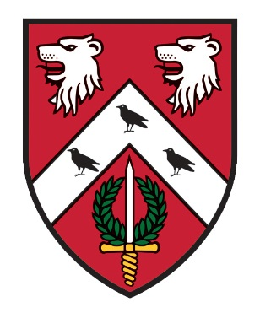
St. Anne’s College
Catering Department
2025/26
OPENING TIMES

Dining Hall - Monday – Friday - Breakfast – 08.00 – 09.30
Lunch – 12.15 – 13.45
Dinner – 18.15 – 19.30
Saturday & Sunday - Brunch – 11.00 – 13.00

(On occasions these times may vary so please remember to keep checking your emails, the noticeboards in Hartland corridor or in the entrance to the Dining Hall)

STACS - Monday - Friday - 10.00 – 17.00

Bar - Tuesday - Saturday - 19.00 – 23.00
(with 20 minutes “drinking up time”)

To make purchases in the Dining Hall, STACS & Bar you will need to ‘top up’ your University card in advance (there is no overdraft facility on your card), using your SSO at
https://meals.st-annes.ox.ac.uk/meals/
The screen will give you a choice of topping up your food account or your bar account

***

STACS
COME DOWN AND CHECK IT OUT!
Missed breakfast, or just wanting a coffee whilst working on your laptop, this is the place for you!

We serve -
- Homemade Pizza with your choice of toppings
- Homemade Panini, Baguettes and Toasties

Other items available are:-
- Hot & Cold Drinks, including wine and beers
- ‘Barefoot Bakery’ Cakes
- Snacks
- Homemade ice creams and sorbets

If you have specific dietary requirements, please ask a member of staff who will be able to help you.
Payment can be either University card or debit/credit card.
DATES FOR YOUR DIARY!
MICHAELMAS TERM
Formal Hall –
24th October 2025 (Wk2)
6th November 2025 (Wk4)
21st November 2025 (Wk6)
3rd December 2025 (Wk8) Graduate CHRISTMAS DINNER (No Guests)
4th December 2025 (Wk8) UG CHRISTMAS DINNER (No Guests)

HILARY TERM
Formal Hall –
30th January 2026 (Wk2)
12th February 2026 (Wk4) FOUNDERS’ DINNER (No Guests)
27th February 2026 (Wk6)
12th March 2026 (Wk8)

TRINITY TERM
Formal Hall –
8th May 2026 (Wk2)
21st May 2026 (Wk4)
5th June 2026 (Wk6)
18th June 2026 (Wk8) FAREWELL (No Guests)

***
ONLINE MEAL BOOKING

Go to https://meals.st-annes.ox.ac.uk/meals/ on your PC or mobile phone QR code below.

- Meals available to book online are Formal Hall & Subject Family Events.
- The meal booking system allows you to book in for dinners up to ten days in advance and closes two days prior to the event at 11.00hrs.
- You are able to specify for each meal what type of meal is required ie meat, vegetarian, vegan and specify any other dietary requirements for both you & your guests.
- Up to 3 guests can be registered for Formal Halls. No guests are allowed to Subject Family Events.
- You will need to bring your University Card with you to dinner. The system checks those attending the dinner have pre - booked.
- Please remember to request ‘wine or non-alcoholic drink’ if required at Formal Hall and to book your seat on the table plan.

